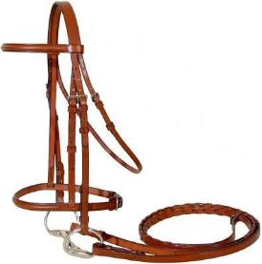
Tack Sale
Saturday, May 22, 2021
NEW LOCATION: Marquette County Fairgrounds,
715 M-553 Marquette, MI 49855
Setup: 10 AM– Noon
Shopping: Noon to 3PM (sorry no early sales)
Space Rental: $25 includes one table and two chairs
All items you are selling must fit on, under or within 2 feet of your table. If you need a larger space, please contact us. Example: if you have ‘several’ saddles, we can give you options on additional space. You can bring your own tent/tables.
Must Preregister by 5/14/2021
We will be using two unheated barns for tables– spaced appropriately.
If you register after the barns are full – you can setup outside. So…register early!
Each person selling tack will be responsible for manning their own table. Be sure to bring your own ‘change.’ (This is not a “check-in” process like we used to do!) Also, please provide hand sanitizer at your table.
Attendees: BRING Cash – you may be buying from multiple vendors and each vendor may or may not accept checks.
** No concessions this year** Masks MUST be worn IN the barns**
Marquette County Horse Club is not responsible for lost or stolen items
If you have any questions, please go to our Facebook page and message us or text (906) 250-5153 (Cindy) & (906) 250-7234 (Lisa)

Tack Sale Registration Form

Name: _______________________________________________
Address: ______________________________________________
Cell phone number: _____________________________________
Email address: _________________________________________

# of spaces needed @ $25/table: ______________
Money MUST accompany registration.

Make your checks out to: MCHC
Mail to: PO Box 104
Gwinn, MI 49841

We will be posting on Facebook and other social media locations so if you’d like us to advertise something special that you plan to sell— let us know!

If you have any questions, please go to our Facebook page and message us or text (906) 250-5153 (Cindy) & (906) 250-7234 (Lisa)

